Project Report

Autonomous Logistics Researcher Agent
  - An AI-Powered Multi-Agent System for Warehouse Operations Analysis & Research

  - Course Name: Agentic AI
Institution Name: Medicaps University
Datagami Skill Based Course

Sr no | Student Name | Enrolment Number
1 | Sarthak Dubey | EN22CS301876
2 | Shivatimika Pawar | EN22CS301918
3 | Sangini Agrawal | EN22CS301863
4 | Samrath Singh | EN22CS301855
5 | Shivam Kushwaha | EN22CS301904
6 | Satyam Patel | EN22CS301885

Group Name: Group 10D8
Project Number: AAI-45
Industry Mentor Name:
University Mentor Name:
Academic Year: 2025-2026

Table Of Contents
Sr. No | Section | Page No
1. | Summary
2. | Introduction
 | 2.1 Background of the Study
 | 2.2 Overview of Agentic AI
 | 2.3 Importance of Retrieval Augmented Generation (RAG)
 | 2.4 Industry Context: AI in Logistics & Operations
3. | Problem Statement & Objectives
 | 3.1 Problem Statement
 | 3.2 Project Objectives
 | 3.3 Scope of the Project
4. | Proposed Solution
 | 4.1 Key Features
 | 4.2 Overall Architecture / System Workflow
 | 4.2.1 High-Level Architecture Diagram
 | 4.2.2 System Workflow Flowchart
 | 4.2.3 RAG Pipeline Diagram
 | 4.3 Agent Design & Role Definition
 | 4.3.1 Orchestrator Agent
 | 4.3.2 Knowledge Retrieval Agent
 | 4.3.3 Operational Analytics Agent
 | 4.3.4 Context Memory Agent
 | 4.4 RAG Implementation Strategy
 | 4.5 System Design Decisions
 | 4.6 Tools & Technologies Used

Sr. No | Section | Page No
5. | System Implementation
 | 5.1 Query Routing Mechanism
 | 5.2 Dataset Processing Module
 | 5.3 Memory & Knowledge Storage
 | 5.4 LLM Integration & Response Generation
6. | Results & Output
 | 6.1 Screenshots / System Outputs
 | 6.2 Analytical Reports Generated
 | 6.3 Performance Observations
 | 6.4 Key Outcomes
7. | Limitations
8. | Conclusion
9. | Future Scope & Enhancements
10. | References

- Summary
The Autonomous Logistics Research Agent project presents the design and implementation of a multi-agent AI system capable of autonomously analyzing warehouse operations and performing industry research. The system integrates CrewAI, LangChain, and Groq LLM within a Retrieval Augmented Generation (RAG) framework to provide accurate, structured insights from operational data and external knowledge sources.

Key components of the system include:
- Orchestrator Agent: Assigns and coordinates tasks among specialized agents.
- Knowledge Retrieval Agent: Retrieves industry-relevant information from web sources.
- Operational Analytics Agent: Processes and interprets warehouse datasets.
- Context Memory Agent: Stores insights in vector memory for future queries, enabling continuous learning.

The system addresses critical operational challenges, including delayed insights, manual data analysis, and dependency on human analysts. It supports natural language queries and generates structured, actionable reports detailing root causes, operational insights, best practices, and recommendations.
The solution demonstrates potential for improving decision-making speed, operational accuracy, and knowledge retention within warehouse and logistics management environments.

- Introduction

The warehouse and logistics industry generates large volumes of operational data, including order details, picking times, delivery schedules, and transportation modes. Traditional analytical methods rely on manual processing, which is often time-consuming, error-prone, and dependent on human expertise. With modern supply chains becoming increasingly complex, organizations face challenges in extracting actionable insights quickly and accurately.

To address these challenges, this project proposes an Agentic AI approach that combines multi-agent collaboration with Retrieval Augmented Generation (RAG). The system is designed to interpret natural language queries, analyse structured warehouse data, and perform industry research autonomously. By leveraging Groq LLM within a multi-agent framework, the system aims to provide reliable, context-aware insights to support operational decision-making, while ensuring scalability and continuous knowledge accumulation.

This introduction establishes the industry context, highlights the limitations of traditional methods, and outlines the high-level AI-based solution approach, setting the stage for the detailed design sections that follow.

  - Background of the Study
Modern warehouse operations generate large-scale operational data, including order details, picking times, transport modes, and delivery delays. Manual analysis of this data is time-consuming, error-prone, and heavily dependent on human expertise. Traditional reporting methods do not provide real-time insights, making it difficult to identify root causes of operational inefficiencies.
The increasing adoption of AI and automation in logistics has created an opportunity for autonomous AI systems that can analyze data, perform research, and deliver actionable insights with minimal human intervention.

  - Overview of Agentic AI in Logistics
Agentic AI refers to systems capable of autonomous, goal-driven decision-making. In the logistics domain, such systems enable intelligent operational support by:
- Executing tasks autonomously without direct supervision.
- Collaborating across specialized agents, including Orchestrator Agent, Knowledge Retrieval Agent, Operational Analytics Agent, and Context Memory Agent.
- Continuously learning from new data and historical insights stored in vector memory.
- Providing context-aware recommendations by leveraging Groq LLM for natural language understanding and structured response generation.
This approach allows logistics operations to achieve faster decision-making, reduced manual effort, and reliable analysis while maintaining scalability and adaptability in dynamic supply chain environments.

  - Importance of Retrieval Augmented Generation (RAG)
Retrieval Augmented Generation (RAG) combines retrieval-based methods with large language models (LLMs) to:
- Efficiently access structured and unstructured knowledge from datasets and external sources.
- Reduce hallucinations by grounding responses in factual operational data and industry research.
- Generate accurate, context-aware insights that are actionable for logistics decision-making.
In this project, RAG is integrated with a multi-agent system leveraging Groq LLM, ensuring that both dataset queries and industry research are answered reliably. This integration maintains consistency, accuracy, and trustworthiness in all generated reports.

2.4 Industry Context: Warehouse & Supply Chain Operations
The logistics and warehouse industry faces multiple challenges:
- High-volume, dynamic datasets with continuous updates
- Operational delays due to manual oversight
- Difficulty in identifying process bottlenecks
- Dependency on expert analysts for reporting and decision-making
An autonomous AI system capable of real-time analysis, research, and reporting can significantly improve efficiency, decision-making, and knowledge retention across the supply chain.

- Problem Statement & Objectives
3.1 Problem Statement
Warehouses generate large volumes of operational data, such as:
- Order details and statuses
- Picking and packing times
- Transportation modes and routes
- Delivery delays
Current practices for analyzing this data are manual and labor-intensive, leading to:
- Delayed insights that affect operational efficiency
- Difficulty identifying root causes of delays or inefficiencies
- Dependency on human analysts, making scalability challenging
- Limited integration of operational data with external industry knowledge
These challenges highlight the need for an autonomous AI system capable of analyzing warehouse operations, performing research, and generating actionable recommendations without manual intervention.
3.2 Project Objectives
The primary objective of this project is to develop an AI-powered autonomous logistics research system that can:
- Understand natural language queries from users using Groq LLM.
- Analyse warehouse operational datasets efficiently through the Operational Analytics Agent.
- Perform industry-level research on logistics and warehouse technologies via the Knowledge Retrieval Agent.
- Generate structured recommendations and reports integrating insights from both data and research, coordinated by the Orchestrator Agent.
- Store knowledge in a memory system managed by the Context Memory Agent, enabling continuous learning and retrieval for future queries.
The system is designed to bridge the gap between operational data analysis and strategic decision-making in warehouse and logistics operations.

3.3 Scope of the Project
- Analysis of warehouse datasets (orders, delays, picking times, transport modes) using the Operational Analytics Agent.
- Autonomous industry research using external web sources via the Knowledge Retrieval Agent.
- Generation of structured reports containing root causes, operational insights, best practices, and recommendations, coordinated by the Orchestrator Agent and powered by Groq LLM.
- Multi-agent AI system design, including Orchestrator Agent, Knowledge Retrieval Agent, Operational Analytics Agent, and Context Memory Agent.
- Integration of Retrieval Augmented Generation (RAG) to ensure accurate, data-grounded, and context-aware responses.
Out of scope:
- Real-time IoT integration (planned for future enhancement).
- Deployment across multiple warehouse sites (future scalability).
- Predictive logistics modeling beyond analysis and recommendation.

4. Proposed Solution
The proposed solution is a multi-agent AI system designed to autonomously analyse warehouse operations and perform industry research. The system functions like a corporate team, where each agent has a clearly defined role to ensure efficient task execution and accurate insights. Integration of CrewAI, LangChain, and Groq LLM with RAG ensures structured, reliable, and data-grounded responses to user queries.

4.1 Key Features
- Autonomous Query Understanding: Interprets natural language queries using Groq LLM.
- Multi-Agent Collaboration: Specialized agents coordinate to execute tasks efficiently.
- Data Analysis & Research: Combines warehouse dataset evaluation (Operational Analytics Agent) with industry research (Knowledge Retrieval Agent).
- Knowledge Storage: Insights and recommendations are stored in the Context Memory Agent for future queries.
- RAG-Based Response Generation: Ensures all answers are grounded in operational data and relevant external knowledge.

4.2 Overall Architecture / System Workflow
The system workflow is designed to provide efficient, accurate, and actionable insights from warehouse operations and industry research. The key steps are:
- User Query Input: A user submits a question regarding warehouse operations or industry best practices.
- Query Type Detection: The Router Module identifies whether the query requires dataset analysis or external research.
- Agent Execution:
  - Operational Analytics Agent handles dataset-related queries.
  - Knowledge Retrieval Agent performs web-based industry research.

- Response Generation: Groq LLM, integrated with RAG, produces a structured and reliable report.
- Knowledge Storage: Generated insights are stored in the Context Memory Agent for future retrieval and continuous learning.
This workflow ensures timely, accurate, and context-aware outputs while minimizing human dependency and supporting scalable decision-making.

4.2.1 High-Level Architecture Diagram
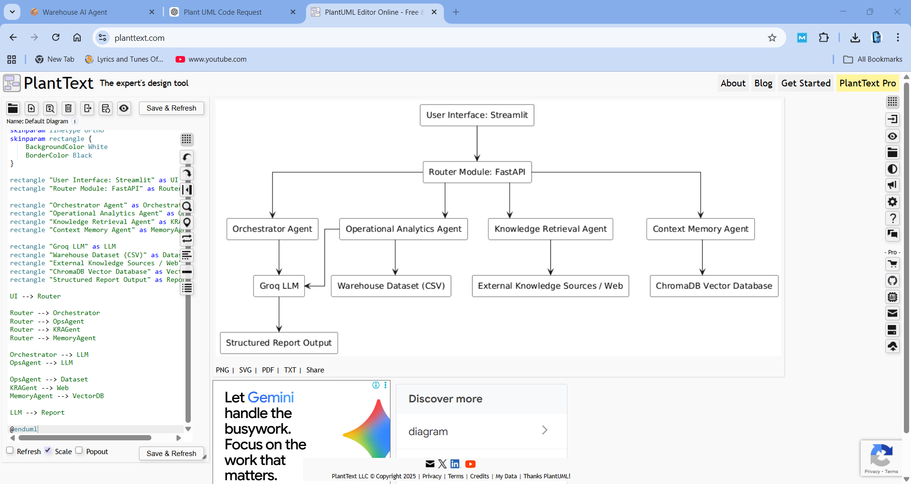
4.2.2 System Workflow Flowchart
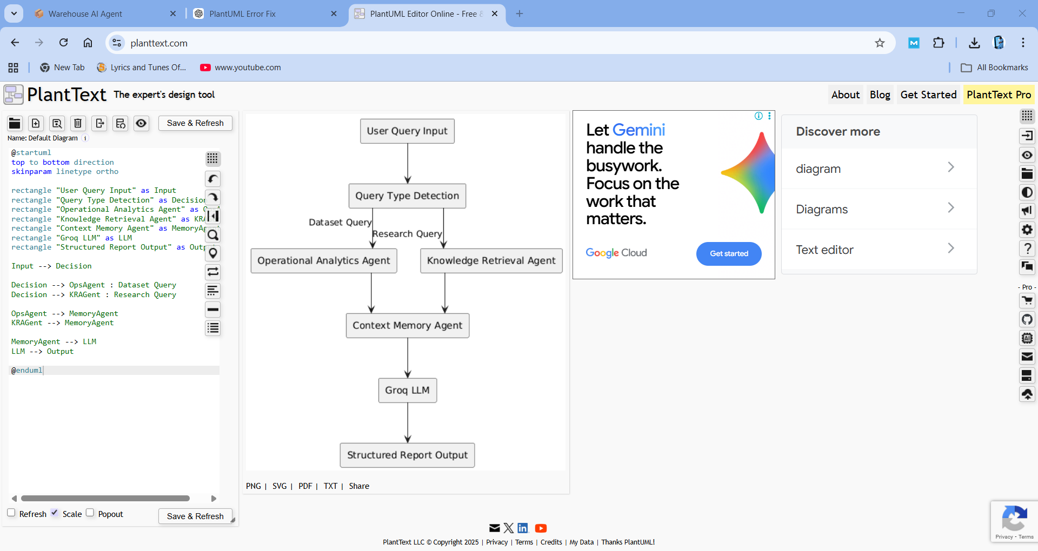

4.2.3 RAG Pipeline Diagram

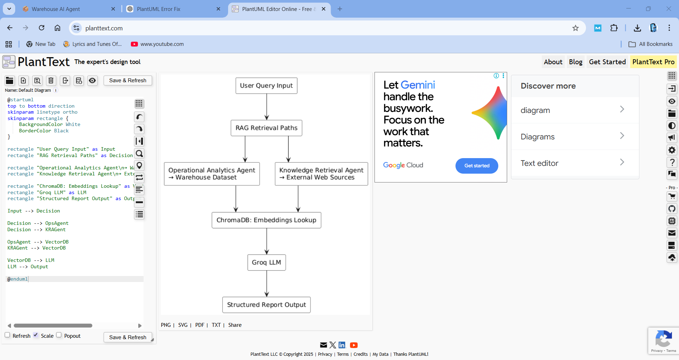

4.3 Agent Design & Role Definition
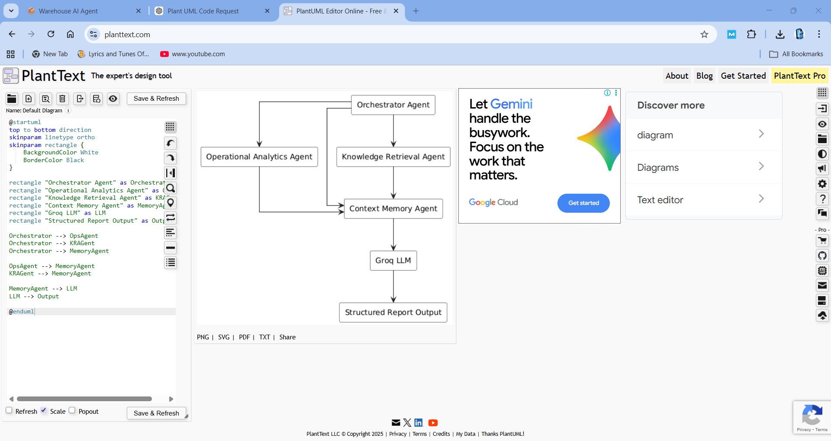

4.3.1 Orchestrator Agent
- Coordinates and assigns tasks among all agents.
- Monitors progress and ensures queries are completed efficiently and accurately.

4.3.2 Knowledge Retrieval Agent
- Performs industry-level web research.
- Extracts relevant data, trends, and best practices for decision support.

4.3.3 Operational Analytics Agent
- Processes and interprets warehouse datasets.
- Retrieves records, identifies delays, and generates statistical insights.

4.3.4 Context Memory Agent
- Stores insights and embeddings for future queries.
- Supports continuous learning and RAG-based retrieval to ensure reliable responses.

4.4 RAG Implementation Strategy
- Retrieval Augmented Generation (RAG) combines retrieval-based methods with Groq LLM to produce data-grounded and context-aware responses.
- Embeddings are generated using Sentence Transformers and stored in ChromaDB for efficient retrieval.
- RAG minimizes hallucinations and ensures reliable insight generation from both warehouse datasets and external industry sources.

4.5 System Design Decisions
- Multi-agent architecture was selected to ensure modularity, scalability, and clear task delegation.
- FastAPI backend enables RESTful API integration for seamless data access and internal communication.
- Streamlit frontend allows interactive query submission and visualization of structured reports.
- Vector database (ChromaDB) was chosen for high-performance storage and retrieval of embeddings.
- LLM selection: Groq provides efficient, accurate, and context-aware language generation, integrated with RAG for reliable insights.
4.6 Tools & Technologies Used
Component | Technology / Framework | Purpose
Backend | Python, FastAPI | REST APIs, query processing
AI Framework | CrewAI, LangChain | Agent orchestration, LLM integration
LLM | Groq | Natural language understanding and response generation
Vector Database | ChromaDB | Storing embeddings and knowledge retrieval
Embeddings | Sentence Transformers | Converting textual data into vectors for retrieval
Frontend | Streamlit | User interface and query input

5. System Implementation
The Autonomous Logistics Research Agent system is implemented as a modular multi-agent architecture that handles user queries, processes warehouse datasets, performs industry research, and stores knowledge for continuous learning. The system integrates CrewAI for agent orchestration, LangChain for LLM workflow management, and ChromaDB for vector-based retrieval.

Data Flow Diagram (DFD)
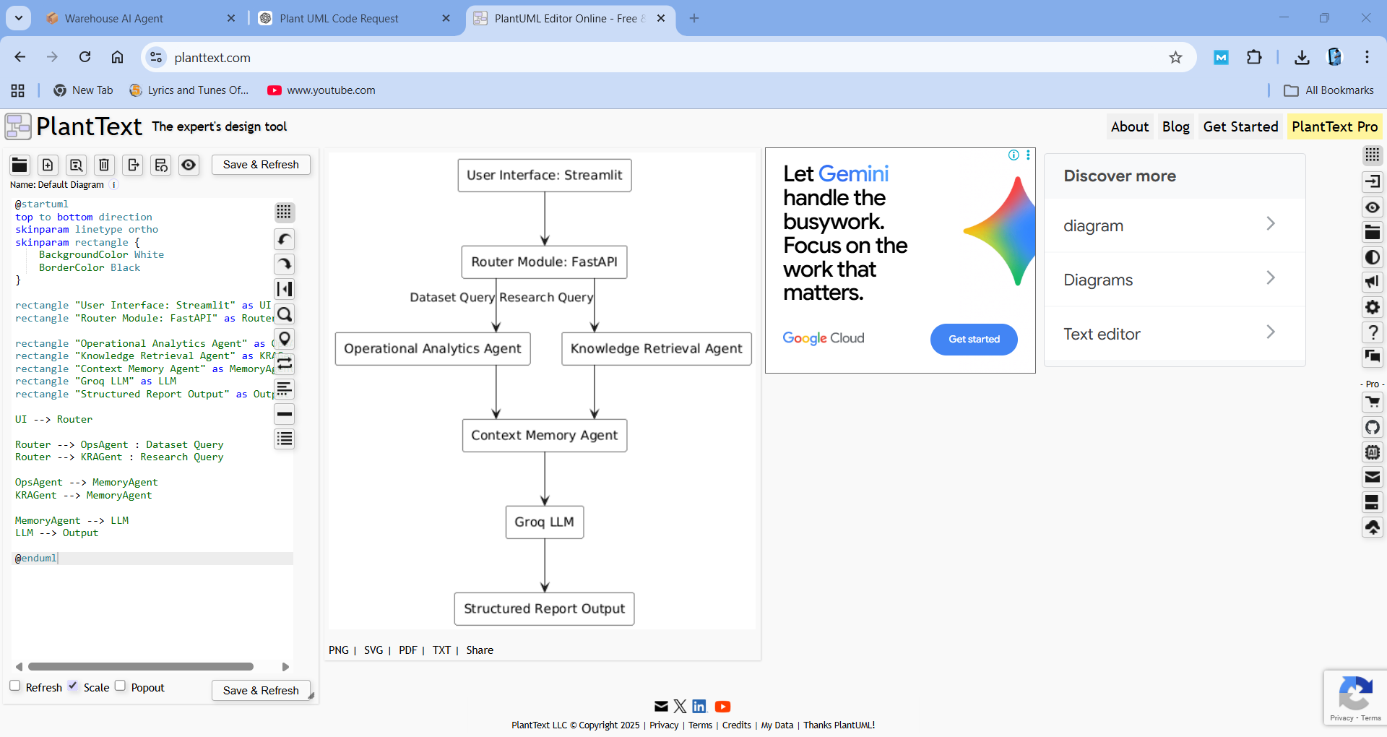

5.1 Query Routing Mechanism
- The Router Module receives user queries via the frontend (Streamlit).
- Determines query type based on input:
  - Dataset Query: Questions regarding orders, delays, picking times, or transport modes.
  - Research Query: Industry-level questions such as warehouse automation technologies or best practices.

- Routes the query to the appropriate agent:
- Operational Analytics Agent for dataset queries.
- Knowledge Retrieval Agent for research queries.
- Logs the query for traceability and future analysis.
5.2 Dataset Processing Module
- Warehouse datasets (CSV/structured tables) are preprocessed to handle missing values, normalization, and type conversion.
- Implements indexing and filtering mechanisms for rapid retrieval of records.
- Supports complex queries, e.g., retrieving order history, delay reasons, or transport analysis.
- Generates structured summaries of dataset information for downstream LLM processing.

5.3 Research & Retrieval Module
- The Knowledge Retrieval Agent performs web-based retrieval using LangChain pipelines.
- Integrates RAG to combine retrieved knowledge with Groq LLM generation.
- Ensures content is relevant, accurate, and data-grounded, minimizing hallucinations.
- Supports queries such as:
- “Latest warehouse automation technologies”
- “Best practices for reducing picking time”
- Outputs structured information to the LLM for report generation.

5.4 Memory & Knowledge Storage
- Knowledge from previous queries and research is stored in ChromaDB vector database.

- Embeddings are generated using Sentence Transformers for semantic search and retrieval.
- Context Memory Agent ensures:
- Faster responses to repeated or similar queries.
- Continuity of knowledge across sessions.
- Continuous learning for improved recommendations.

5.5 LLM Integration & Response Generation
- Groq LLM is integrated for structured natural language response generation.
- Combines:
- Dataset outputs from Operational Analytics Agent.
- Industry research outputs from Knowledge Retrieval Agent.
- Memory-based context from Context Memory Agent.
- Generates final structured report containing:
  - Root Cause Analysis
  - Insights & Trends
  - Best Practices
  - Actionable Recommendations
- Ensures consistency, accuracy, and professional formatting of outputs.

6. Results & Output
The system was evaluated using warehouse operational datasets and industry research queries. The results demonstrate the system’s capability to process data, perform research, and generate structured reports with minimal human intervention.

6.1 Example Dataset Query
Query: “Details of order 1003”
System Output (Dataset Analysis):
Parameter | Value
Warehouse | Indore
Product | Clothing
Distance | 560 km
Delay | Yes
Picking Time | High

Observation: The Operational Analytics Agent retrieved and summarized relevant data, providing instant access to operational insights without manual effort.
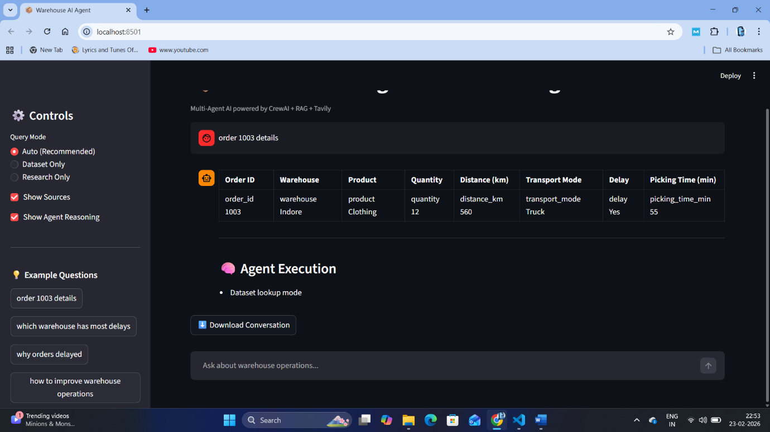

6.2 Example Research Query
Query: “Latest warehouse automation technologies”
System Output (Industry Research):
- Robotics picking systems
- AI-driven demand forecasting
- IoT tracking solutions
- Warehouse Management Systems (WMS)
Observation: The Knowledge Retrieval Agent, integrated with RAG and Groq LLM, successfully aggregated relevant and accurate industry information, significantly reducing the need for manual literature searches.

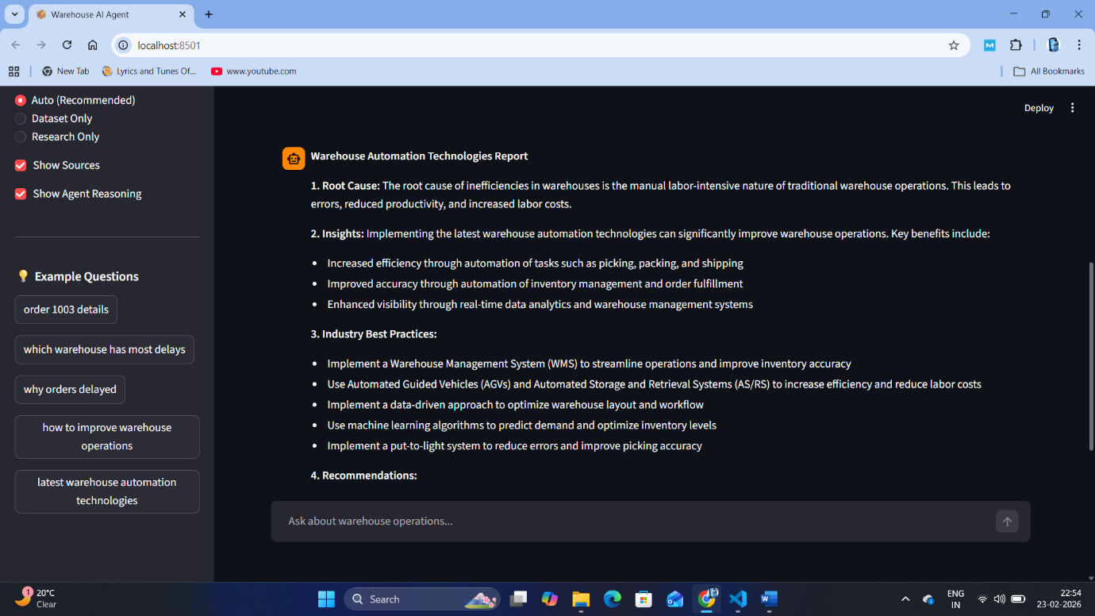

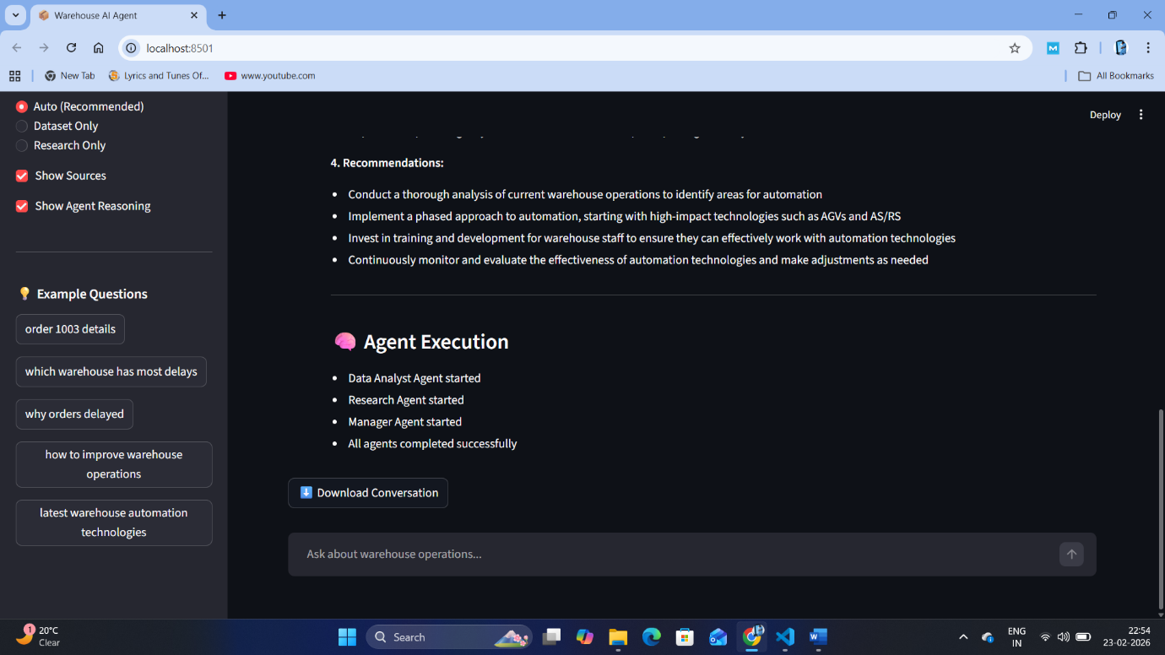

6.3 Generated Structured Report
The system combines dataset and research outputs to produce a structured report:
Example Report Sections:
- Root Cause Analysis: High picking times and transportation delays identified in warehouse Indore.
- Insights: Automation can reduce manual handling and improve throughput.
- Best Practices: Implement robotics picking, AI-based demand forecasting, and WMS integration.
- Recommendations: Prioritize high-delay orders, integrate predictive analytics, and track performance metrics continuously.
Observation: Structured reports are ready-to-use for operational decision-making and provide actionable insights in a concise format.

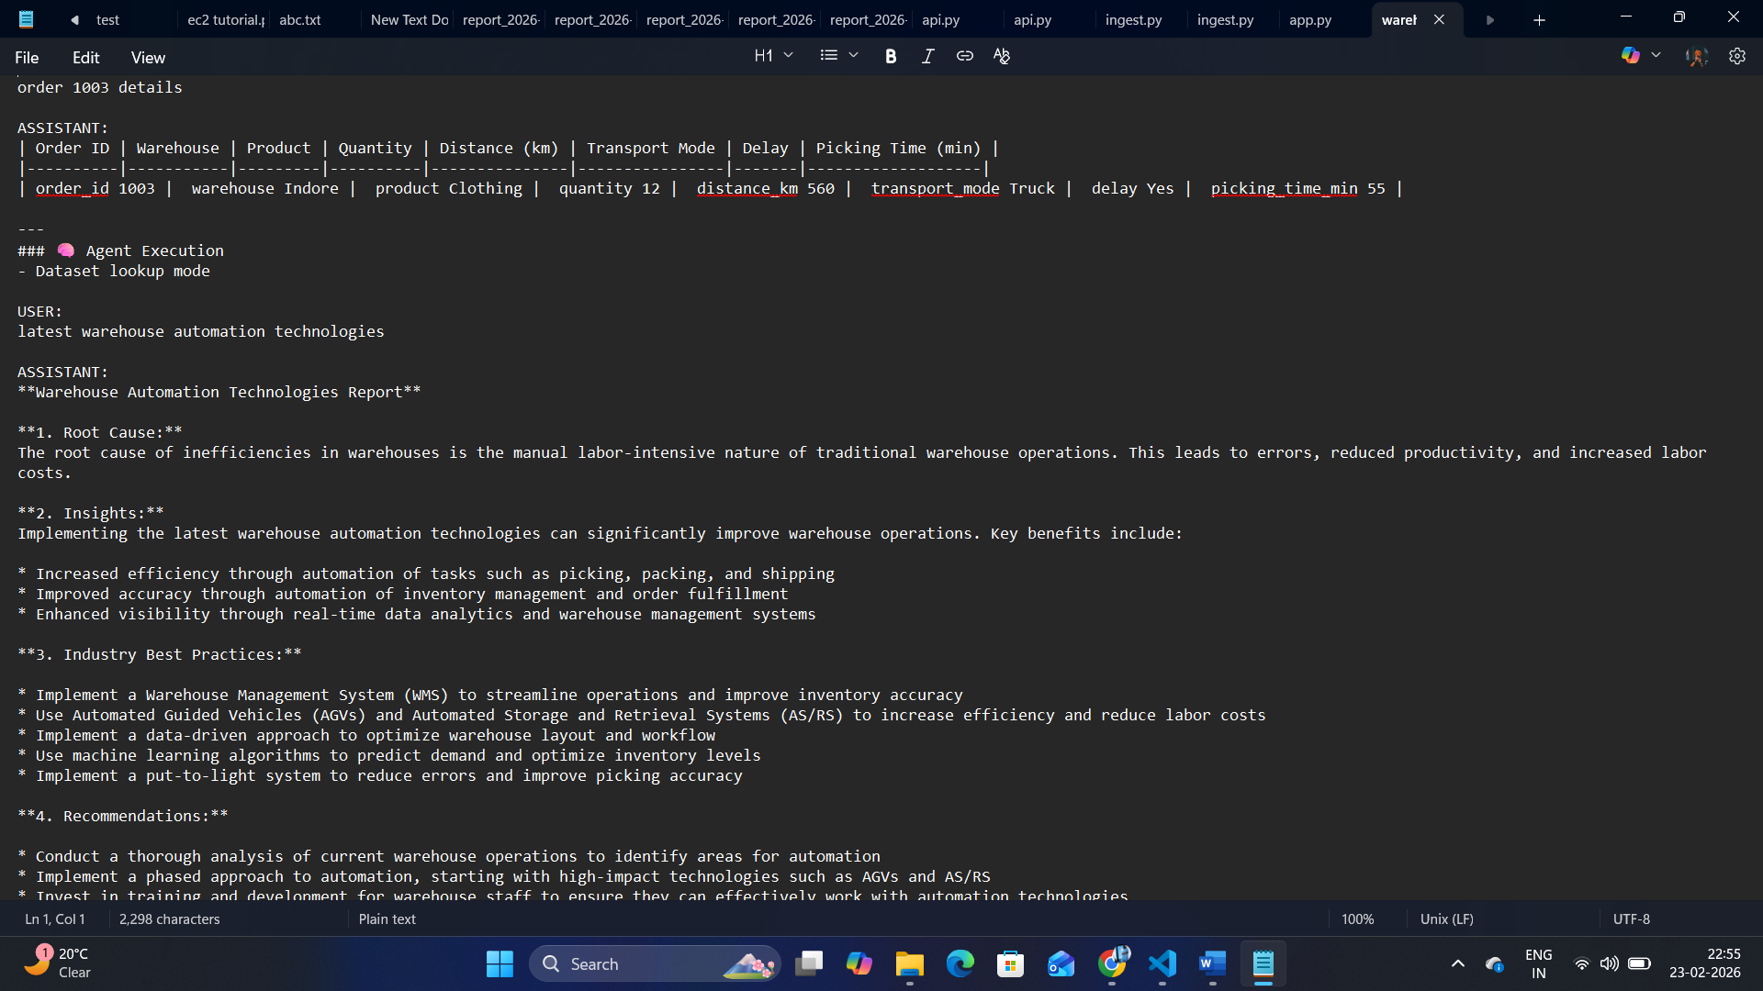

6.4 Advantages
- Automatic Analysis: Eliminates manual data processing.
- Faster Decision-Making: Immediate responses to queries.
- Accurate Insights: RAG ensures data-grounded answers and context-aware answers.
- Continuous Learning: Memory agent stores knowledge for future queries.
- Industry Relevance: Integrates warehouse operational data with the latest industry trends.

7. Limitations
While the Autonomous Logistics Research Agent demonstrates significant operational efficiency, the current implementation has certain limitations:
- Real-time IoT Integration Not Implemented:
  - The system currently analyzes static warehouse datasets.
  - Live sensor data from IoT devices is not yet integrated, limiting real-time operational insights.
- Scalability Constraints:
  - The system has been tested on a single warehouse dataset.
  - Deployment across multiple warehouses may require additional resource allocation and optimization.
- Dependence on Data Quality:
  - Accuracy of analysis and recommendations relies on completeness and correctness of input datasets.
  - Missing or inconsistent data may impact the quality of generated insights.
- Limited Predictive Capabilities:
  - Current implementation focuses on analysis and recommendations rather than predictive modeling for delays or demand forecasting.
- Web Source Reliability:
  - Industry research relies on publicly available sources; inconsistencies or outdated information may affect recommendations.
Despite these limitations, the system provides a robust foundation for autonomous warehouse analysis and industry research, offering scalable and modular design for future enhancements.

8. Conclusion
This project presented the design and implementation of an Autonomous Logistics Research Agent based on a multi-agent architecture integrated with Retrieval Augmented Generation (RAG). The system unifies warehouse dataset analysis and industry research within an AI-driven framework.
The proposed solution successfully demonstrates the following capabilities:
- Interpretation of natural language queries related to warehouse operations.
- Automated analysis of structured logistics datasets.
- Retrieval and synthesis of industry knowledge using RAG.
- Generation of structured, decision-oriented reports.
- Knowledge storage via Context Memory Agent for improved response consistency and continuity.
The multi-agent design, consisting of Orchestrator Agent, Knowledge Retrieval Agent, Operational Analytics Agent, and Context Memory Agent, ensures modularity, scalability, and clear task delegation. Integration of Groq LLM with vector-based retrieval enhances response accuracy and reduces hallucination risks by grounding outputs in relevant data sources.
Overall, the system provides a practical framework for applying Agentic AI in logistics operations, supporting data-driven decision-making and reducing dependency on manual analysis.

9. Future Scope & Enhancements
The current implementation provides a foundational framework for autonomous logistics intelligence. Several enhancements can further extend its capabilities:
9.1 Real-Time IoT Integration
- Integration with live IoT sensors (temperature, shipment tracking, warehouse scanners).
- Real-time monitoring and automated alerts for operational anomalies.

9.2 Predictive Analytics
- Implementation of machine learning models for:
  - Delay prediction
  - Demand forecasting
  - Inventory optimization
- Transition from descriptive analysis to predictive and prescriptive insights.

9.3 Multi-Warehouse Deployment
- Scalable deployment architecture to support multiple warehouse nodes.
- Centralized knowledge aggregation across distributed logistics centers.

9.4 Advanced Dashboard & Visualization
- Development of a smart logistics dashboard.
- Integration of KPI tracking, performance metrics, and interactive analytics visualizations.

9.5 Enhanced Memory Intelligence
- Long-term contextual memory across sessions.
- Adaptive learning from repeated queries and operational trends.

9.6 Enterprise Integration
- Integration with ERP and Warehouse Management Systems (WMS).
- API-based interoperability with existing enterprise software infrastructure.
These enhancements would enable the system to evolve into a comprehensive AI-driven logistics intelligence platform suitable for enterprise-scale deployment.

10. References
10.1 Academic / Research Papers
- Vaswani, A., Shazeer, N., Parmar, N., Uszkoreit, J., Jones, L., Gomez, A. N., ... & Polosukhin, I. (2017). Attention is All You Need. NeurIPS.
- Lewis, P., Perez, E., Piktus, A., Petroni, F., Karpukhin, V., Goyal, N., ... & Riedel, S. (2020). Retrieval-Augmented Generation for Knowledge-Intensive NLP Tasks. NeurIPS.
- Russell, S., & Norvig, P. (2020). Artificial Intelligence: A Modern Approach (4th ed.). Pearson.
- Silver, D., Huang, A., Maddison, C. J., Guez, A., Sifre, L., Van Den Driessche, G., ... & Hassabis, D. (2016). Mastering the game of Go with deep neural networks and tree search. Nature, 529(7587), 484–489.

10.2 Tools & Framework Documentation
- CrewAI. (2023). CrewAI Official Documentation. https://docs.crew.ai
- LangChain. (2023). LangChain Documentation. https://www.langchain.com/docs
- ChromaDB. (2023). Chroma Vector Database Documentation. https://www.trychroma.com/docs
- Streamlit. (2023). Streamlit User Guide. https://docs.streamlit.io
- FastAPI. (2023). FastAPI Framework Documentation. https://fastapi.tiangolo.com
- Groq. (2024). Groq LLM Overview and Documentation.

10.3 Industry / Whitepapers
- McKinsey & Company. (2022). AI in Logistics: Insights and Applications. McKinsey Insights.
- Deloitte Insights. (2021). Warehouse Automation & AI in Supply Chain. Deloitte Research.
- Gartner Research. (2022). Predictive Analytics in Supply Chain. Gartner, Inc.
- PwC. (2021). Artificial Intelligence in Operations and Logistics. PwC Publications.

10.4 Web Articles / Blogs
- Towards Data Science. (2023). Building Retrieval-Augmented Generation Pipelines with LLMs. https://towardsdatascience.com
- Hugging Face Blog. (2023). Vector Databases and Semantic Search for AI Applications. https://huggingface.co/blog
- CrewAI Medium Articles. (2023). Multi-Agent AI Case Studies. https://medium.com/crew-ai
- Groq Cloud Blog. (2024). Applying Groq LLM for Enterprise Workflows.

